Performance upgrades to the BBC Maximo mobile application

Andy Timmins – 24/08/2014

**Document History**

|  |  |  |  |
| --- | --- | --- | --- |
| **Author** | **Date** | **Revision** | **Comments** |
| Andy Timmins | 24/08/2014 | 0.1 | Initial Draft |
|  |  |  |  |
|  |  |  |  |

Contents

Performance Improvements 4

Data Download Performance 4

Interface Performance 4

Risk assessment field added to change status dialog 4

Capture signature button added to change status dialog 5

Branding 5

Application launcher icon 5

# Performance Improvements

## Data Download Performance

After analysing the data downloaded by the application we have found a number of objects are not required by Interserve. By removing these unneeded objects we have gained significant performance improvements.

|  |  |  |  |
| --- | --- | --- | --- |
|  | **Pre-optimisation (Live)** | **Post Optimisation (SIT)** | **Percentage Improvement** |
| Full Refresh Records | 1104 | 280 | **74%** |
| Full Refresh Time | 00:00:51 | 00:00:29 | **43%** |
| Work List Records | 205 | 62 | **69%** |
| Work List Time | 00:00:37 | 00:00:24 | **35%** |

## Interface Performance

The development team have been taking feedback from the business users on the user interface design. The following features have been change/added to make the UI more manageable:

### Risk assessment field added to change status dialog

When changing the status of a record to START the application validates if you have filled out the risk assessment field. If the field has not been populated an error will be displayed and you will have to exit the change status dialog to populate the values. To improve the user experience we have added this field to the dialog so the user doesn’t need to exit to populate the value.

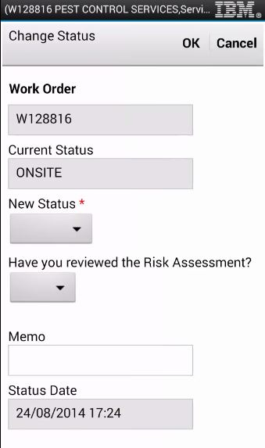

### Capture signature button added to change status dialog

When changing the status of a record to COMP the application validates if you have captured a customer signature. If the signature has not been captured an error will be displayed and you will have to exit the change status dialog to capture the signature. To improve the user experience we have added a capture signature link to the dialog so the user doesn’t need to exit the dialog.

## C:\Users\timminsa\Downloads\capture sig.JPG

## Branding

### Application launcher icon

To improve the look and feel of the application we have added Interserve corporate branding to the application. The work management launch icon is now the Interserve hydra emblem.

